# Import Manufacturers

This document describes the steps needed to move manufacturer data from a BlueCube database instance to and ESO database instance.

## Required Files

In the Manufacturers subject folder of the data extraction and loading package program files, there are 4 SQL scripts.

Step 0 - Manufacturers One Time Only Cleanup

Step 1 - Manufacturers Extract Source DB

Step 2 - Manufacturers Insert Dest DB

Step 3 - Manufacturers Create Manufacturers

Step 0 is on needed if there is existing manufacturer data that needs to be reset. In most cases it should not be used.

## Extract Source DB

Open an instance of SQL Server Management Studio and then open a new query window. Set the database to the main BC/ESO database.

Open and Execute the query “Step 1 - Manufacturers Extract Source DB”. This query will create a bc_extract_manufactuer table and populate the table with the existing set of manufacturers.

Right Click on the database names and navigate to tasks, generate scripts.

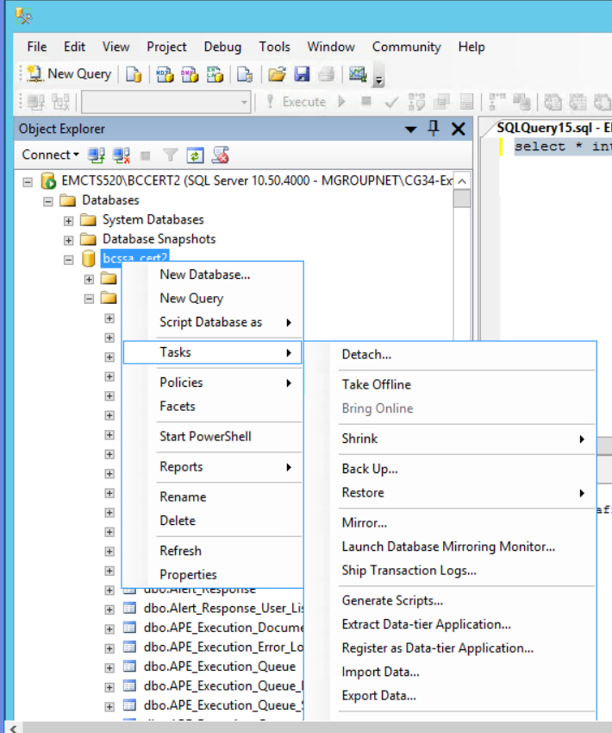

The script generation tool will be displayed.

Select the option to “Select specific database objects”. Expand the list of tables and select the bc_extract_manufacturer table.

Click Next

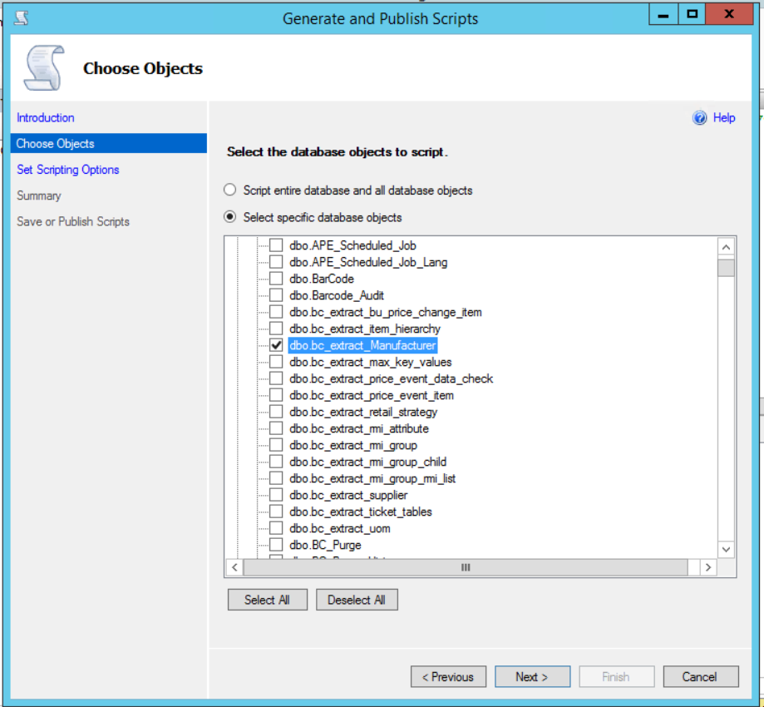

The Scripting Options page will be display, Click on the Advanced button.

Set the “Types of data to script” to “Schema and data”. Click OK.

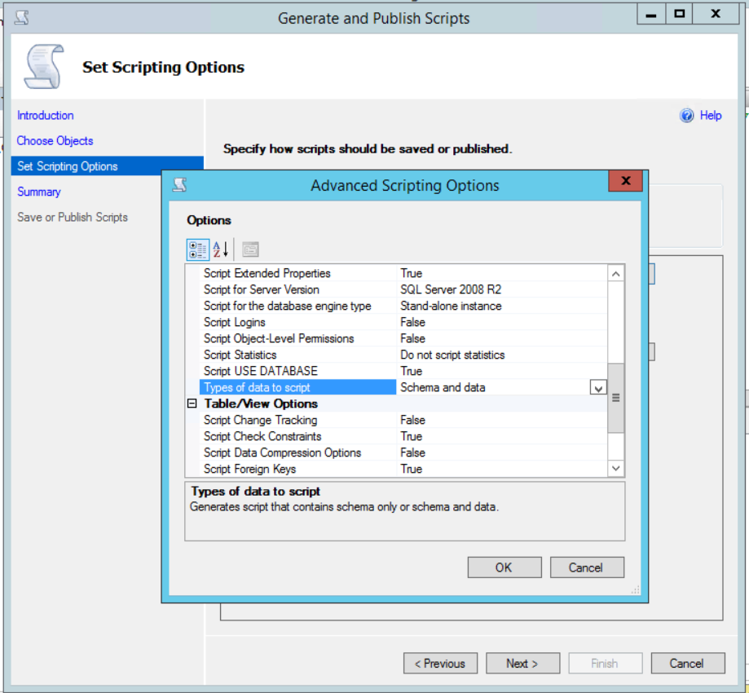

Set the option to “Save to Clipboard”. Click Next.

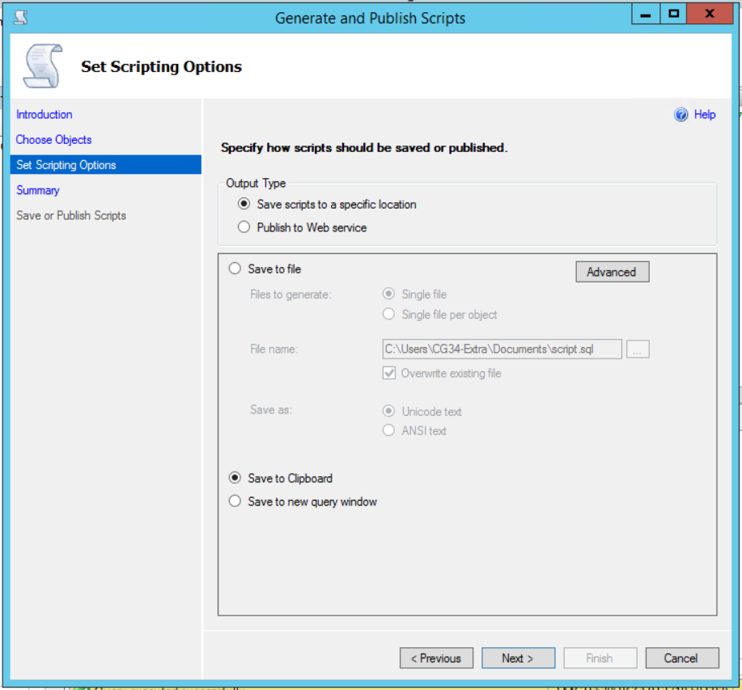

The Summary page will be displayed. Verify the information and Click Next.

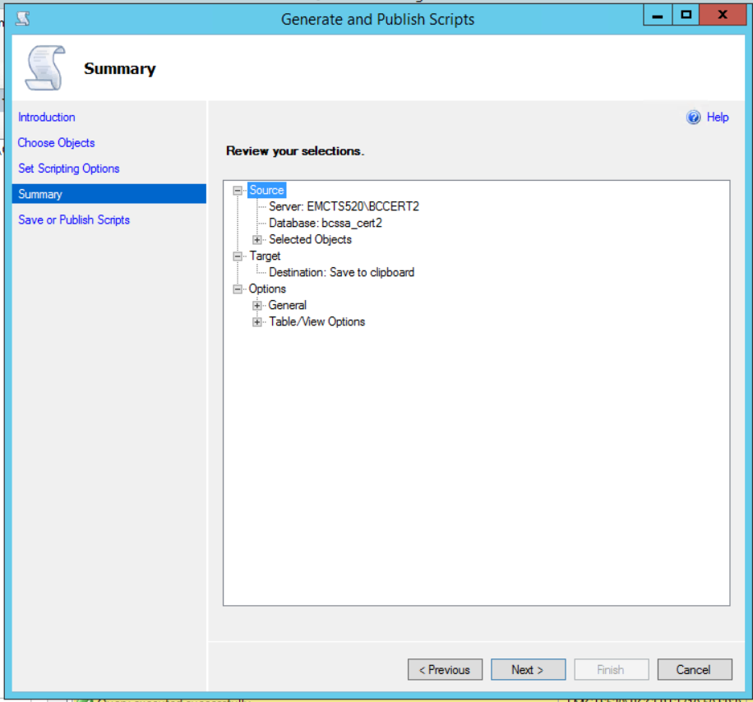

The Generate and Publish Scripts page will be displayed. Verify the result and Click Finish. The page should disappear.

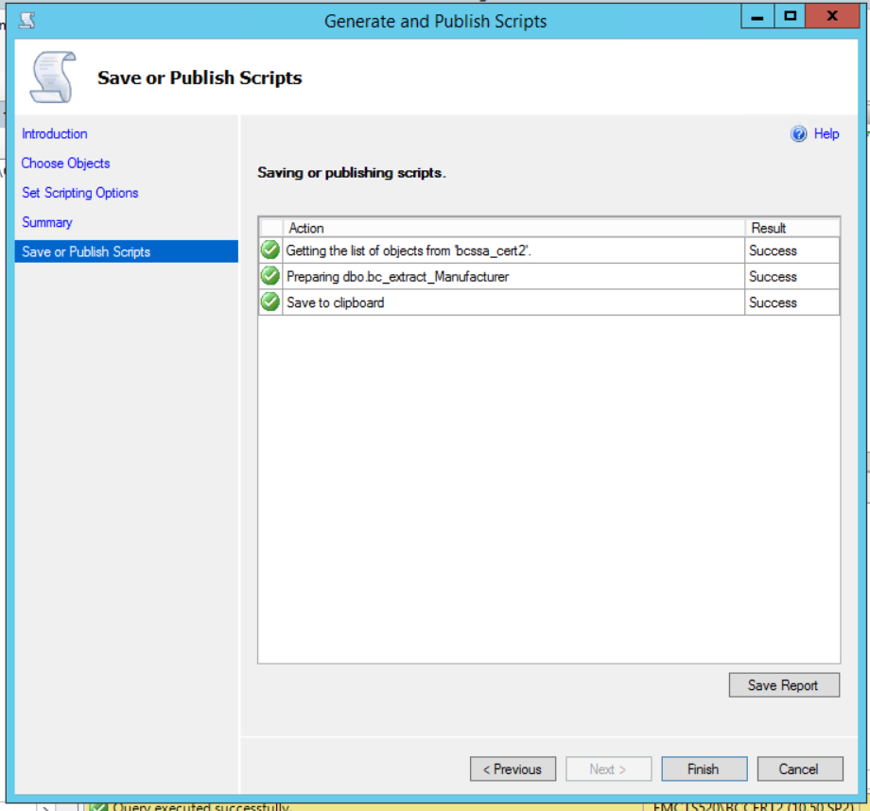

The contents of the script file are now on the clipboard.

## Insert the Destination DB.

Open the script “Step 2 - Manufacturers Insert Dest DB” in a text editor. Select All and clear the contents of the script.

Select Paste to paste the information into the empty file.

Remove the lines of text before the create table command. It will look like this:

USE [bcssa_cert2]

GO

/****** Object: Table [dbo].[bc_extract_Manufacturer] Script Date: 11/05/2018 20:46:18 ******/

SET ANSI_NULLS ON

GO

SET QUOTED_IDENTIFIER ON

GO

Add the following to the top of the script above the create table command. This will ensure that the table is re-created:

IF OBJECT_ID('bc_extract_Manufacturer') IS NOT NULL

DROP TABLE bc_extract_Manufacturer

GO

Save the Query

Open an instance of SQL Server Management Studio and then open a new query window. Set the database to the main BC/ESO database.

Execute the Query “Step 2 - Manufacturers Insert Dest DB”

## Create the Manufacturers

Open an instance of SQL Server Management Studio and then open a new query window. Set the database to the main BC/ESO database.

Execute the Query “Step 3 - Manufacturers Create Manufacturers”.

Ensure that no errors and encountered and that data was inserted into the Manufacturer table.

## Clean up

If needed, go to both the source and destination databases and drop the table bc_extract_Manufacturer.